Adrienne’s Top Picture Books for Reading Power for 2016
Recommended for replenishing, replacing or adding to your Reading Power book collections.

CONNECT
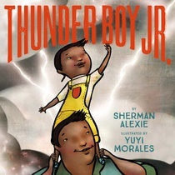  Thunder Boy Jr. Sherman Alexie  Connecting to origin of names | 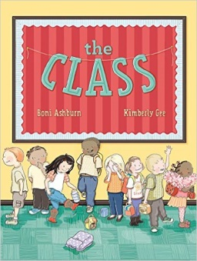  The Class  Boni Ashburn  Connecting to diversity of children, families and routines | 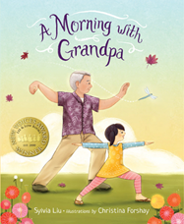  A Morning with Grandpa  Sylvia Liu  Connecting to grandparents | 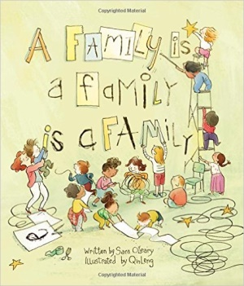  A Family is a Family is a Family  Sara O’Leary  Connecting to families | 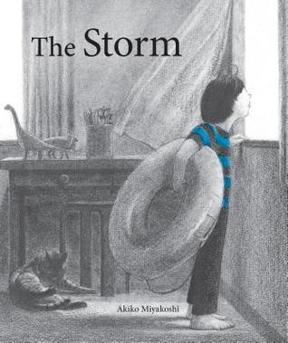  The Storm  Akiko Miyakoshi  Connecting to disappointments

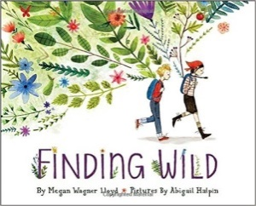  Finding Wild  Megan Wagner Lloyd |   I Hear a Pickle  Rachel Isadora | 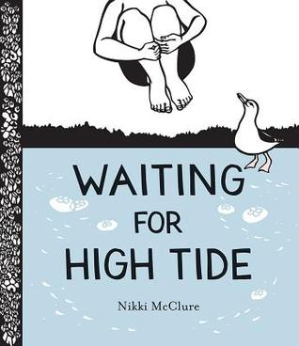  Waiting for High Tide  Nikki McClure | 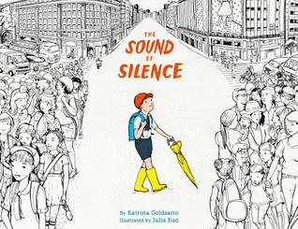  The Sound of Silence  Katrina Goldsaito | 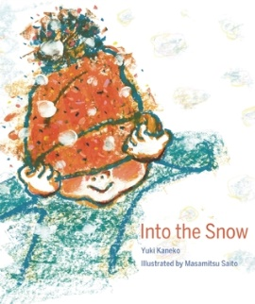  Into the Snow  Yuki Kaneko
VISUALIZE

For more about these books and others, check out Adrienne’s blog. https://readingpowergear.wordpress.com/
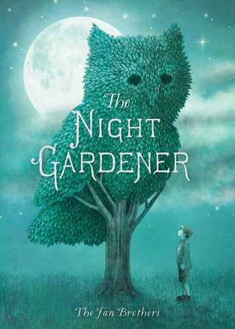  The Night Gardener  The Tan Brothers | 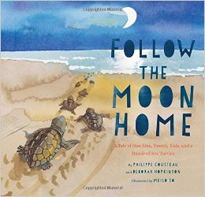  Follow the Moon Home  Deborah Hopkinson | 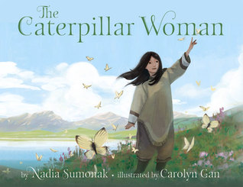  The Caterpillar Woman  Nadia Sammurtok |   The Bear and the Piano  David Litchfield |   The Uncorker of Ocean Bottles  Michelle Cuevas
QUESTION

INFER
  They All Saw a Cat  Brendan Wenzel | 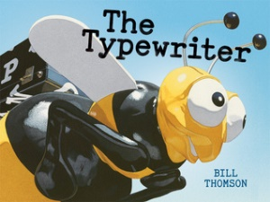  The Typewriter  Bill Thomson | 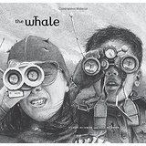  The Whale  Vita Murrow | 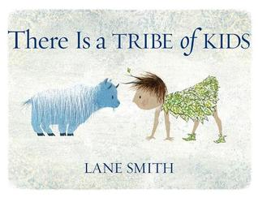  There is a Tribe of Kids  Lane Smith |   Grandad’s Island  Benji Davis

TRANSFORM
  Ada’s Violin: The Story of the Recycled Orchestra of Paraguay  Susan Hood | 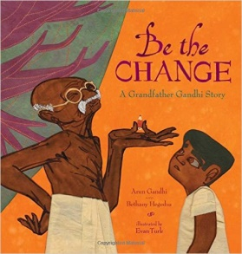  Be the Change: A Grandfather Ghandi Story  Arun Ghandhi | 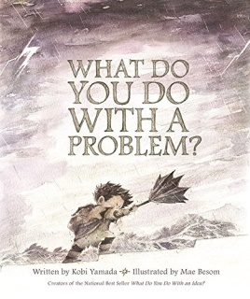  What Do You Do With A Problem?  Kobi Yamada | 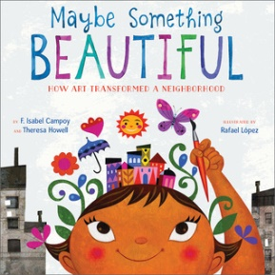  Maybe Something Beautiful: How Art Transformed  F. Isabel Campoy |   Stepping Stones: A Refugee Family’s Story  Margriet Ruurs

